Send Step

Objective

Set the result to HttpResponse.

UI

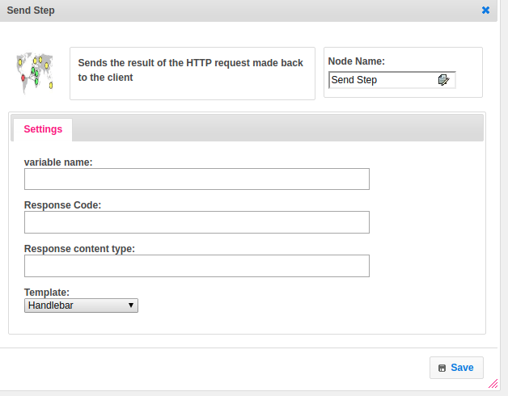

## Attributes:

|  |  |
| --- | --- |
| **Attributes** | **Description** |
| **1. Variable name** | The variable name is used to store the value. |
| **2. Response Code** | When a search engine or website visitor makes a request to a web server, a three-digit HTTP Response Status Code is returned. This code indicates what is about to happen. |
| **3. Response content type** | The Content-Type entity-header is used to indicate the media type of the resource. In responses, a Content-Type header tells the client what the content type of the returned content actually is. ... In requests, (such as POST or PUT ), the client tells the server what type of data is actually sent. |
| **4. Template** | A template used to set the value type.  Value types are two types.  1.hb-HandleBars  2.ftl-Freemarker Template Language. |

## Execution Description

Create a HttpResponse object. Get step variable name value and response content type. If response content type is null then set it to application/json. If response content type is application/json then change the value into gson format otherwise we don’t disturb the data. Set the http response code to response code if the user not provided the http response code then set it as 200 default.